spaceship rpg gAME

Text Based Game

CIS_350 Winter 2024

Professor: Dr Nandigam

Team members

Adrian F Perez-Lopez

Eric Moras

Phuc Le

Contents

Project Information 3

Features 3

Screenshots 3

Project Plan 4

Requirements & Definition 4

Development 4

Verification 4

Maintenance 4

Umbrella Activities 4

Responsibilities 4

Requirements & Specification 5

Use-Cases 5

Natural Language Requirements 5

Traceability Matrix 5

Design 6

Development 7

Code Standards 7

Static Analysis 7

Code Documentation 7

Configuration Management 7

Verification 8

Integration Tests 8

Unit Tests 8

Code Coverage 8

Requirements Coverage 8

Postmortem 9

Earned Value 9

Variances 9

Lessons Learned 9

References 10

# Project Information

The Role-Playing Game (RPG) project is a text-based game that will be a single character (space janitor). The janitor(character) faces different challenges while cleaning shipwrecks; therefore, he acquires different fighting techniques to help him move up in rank, such as cadet and captain, and ultimately becomes a king.

As the character moves through different maps, enemies will get stronger; thus, the player will be rewarded at the end of each challenge. These rewards will help him increase his stats by acquiring various combat tools.

## Features

* Username Input.
  + The user interface will get player’s name; otherwise, Bob will be assigned if user does not want to provide a name.
* Stats.
  + This feature will display how the points are going to be distributed while playing; in addition, the player will be awarded 5 free points to get the game going.
* Game Screen.
  + A map will be displayed showing the player current position.
  + Stat information to keep track of the game.
  + Message screen showing the interaction of the player.

## Screenshots

* 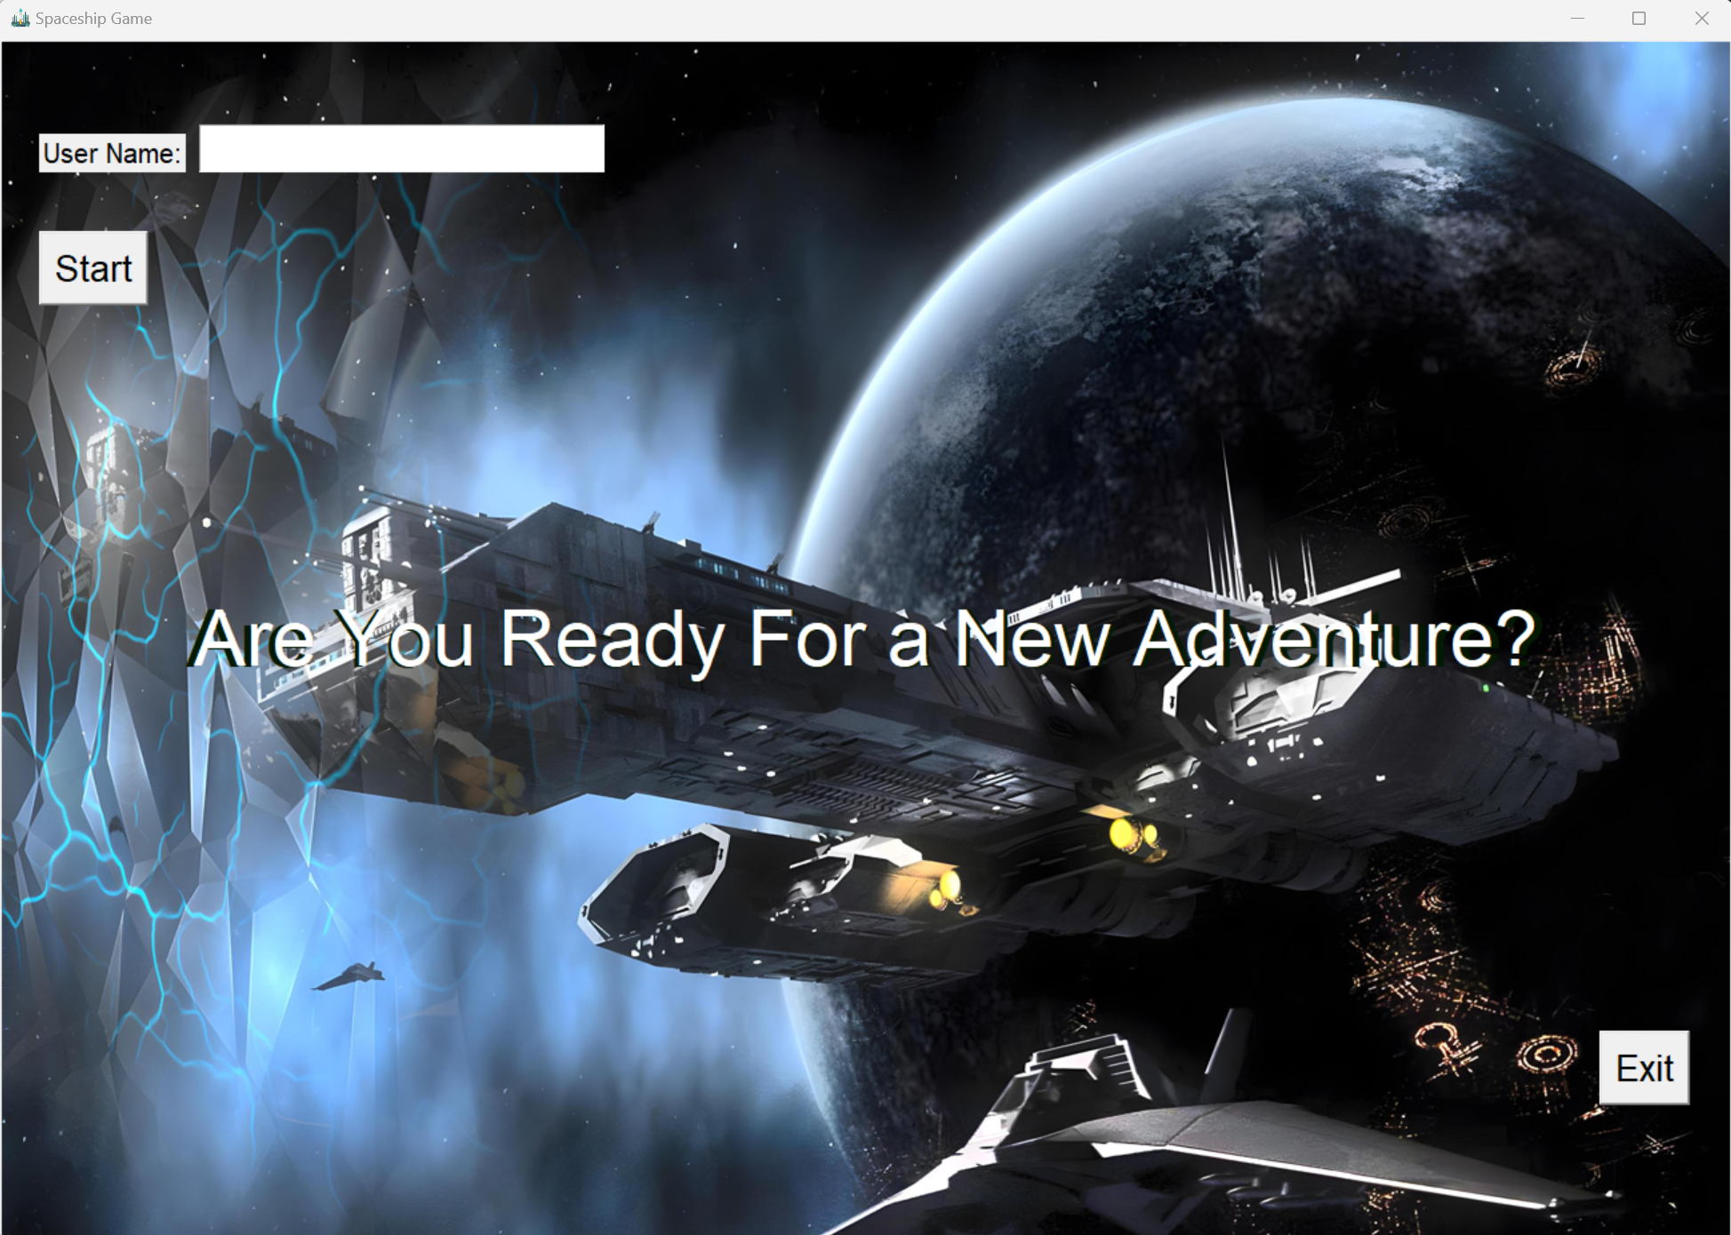Name input.
* 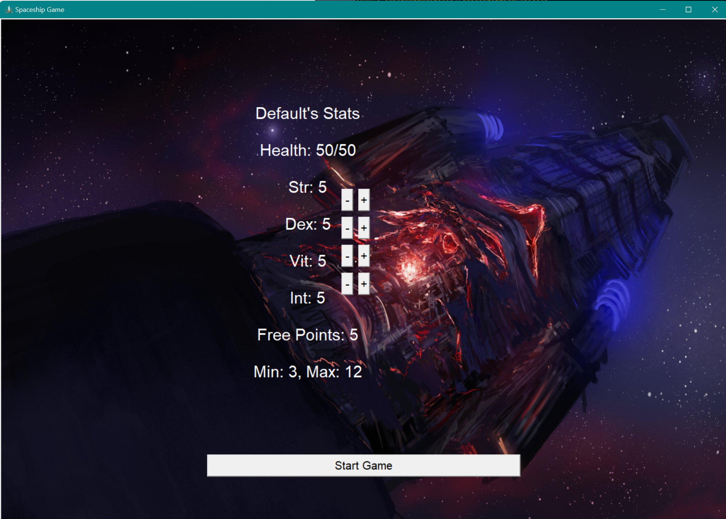Stats display.
* 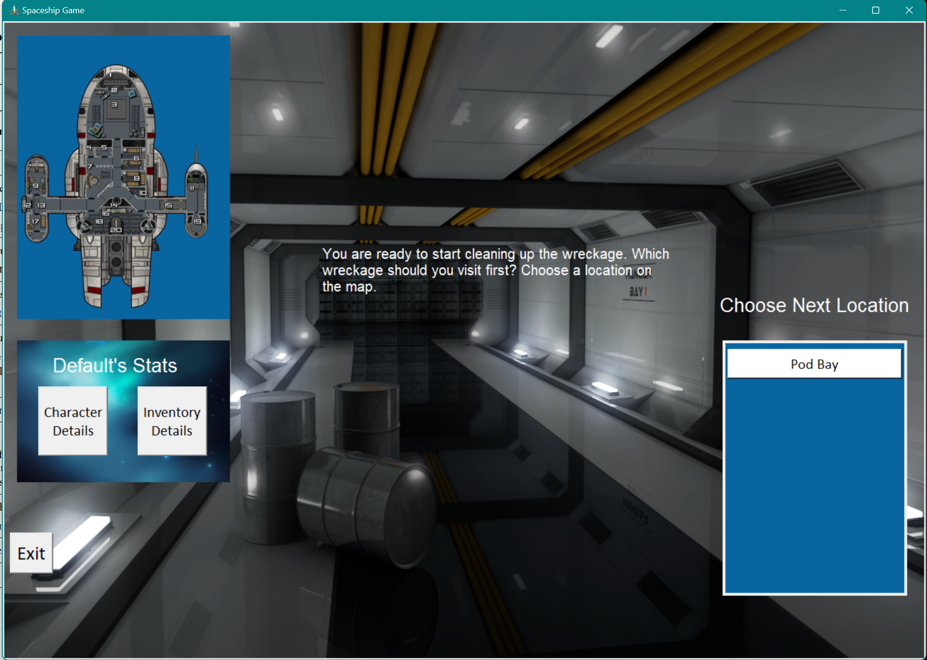Game Screen.
* 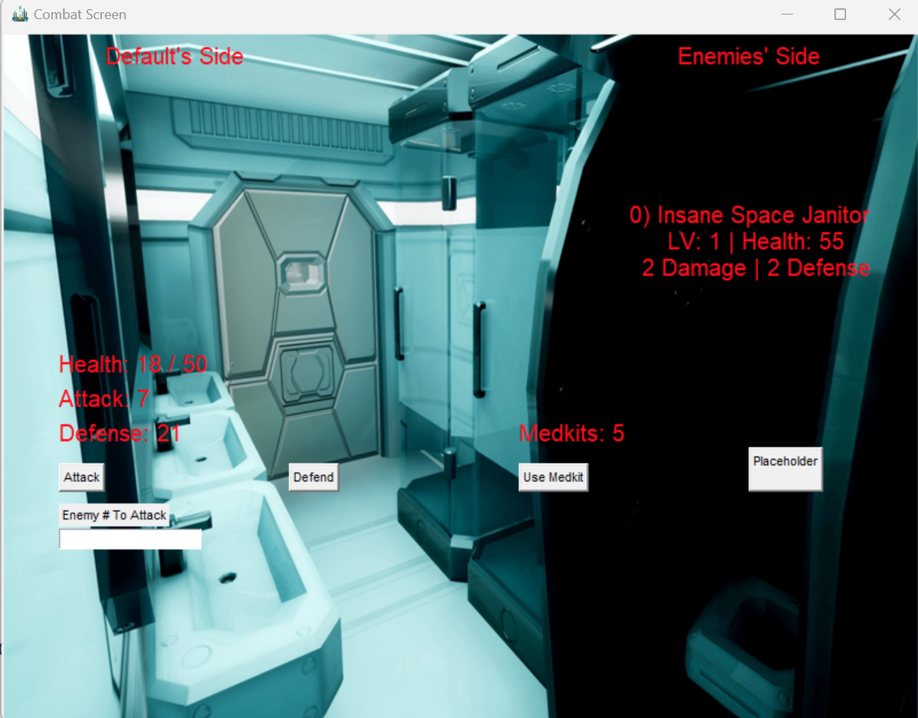Combat Screen (One Room Example)
* 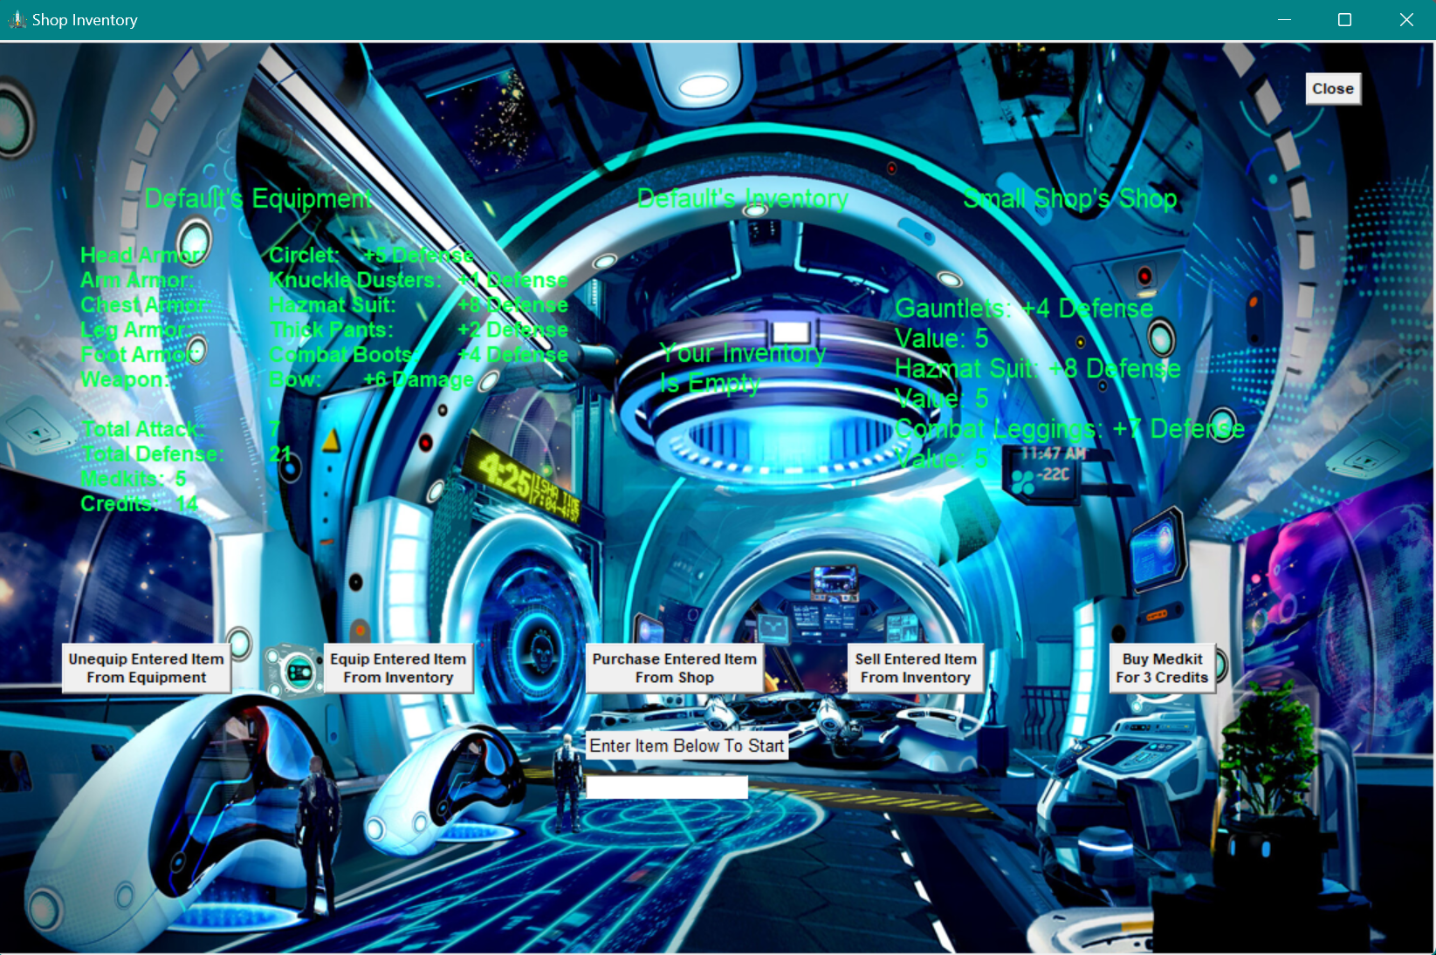Shop Store Screen

# Project Plan

[Overview of Project Plan, including any customizations to the software process model]

## Requirements & Definition

[Plan for requirements and definition detailed here]

## Development

[Plan for development / implementation detailed here]

## Verification

[Plan for verification detailed here]

## Maintenance

[Plan for maintenance (e.g., problems found by prof or during updates for next release) detailed here]

## Umbrella Activities

[Plan for project management and status tracking / meetings detailed here]

## Responsibilities

[Describe the responsibilities of each member, how you plan to break down the work

# Requirements & Specification

## Use-Cases Diagram

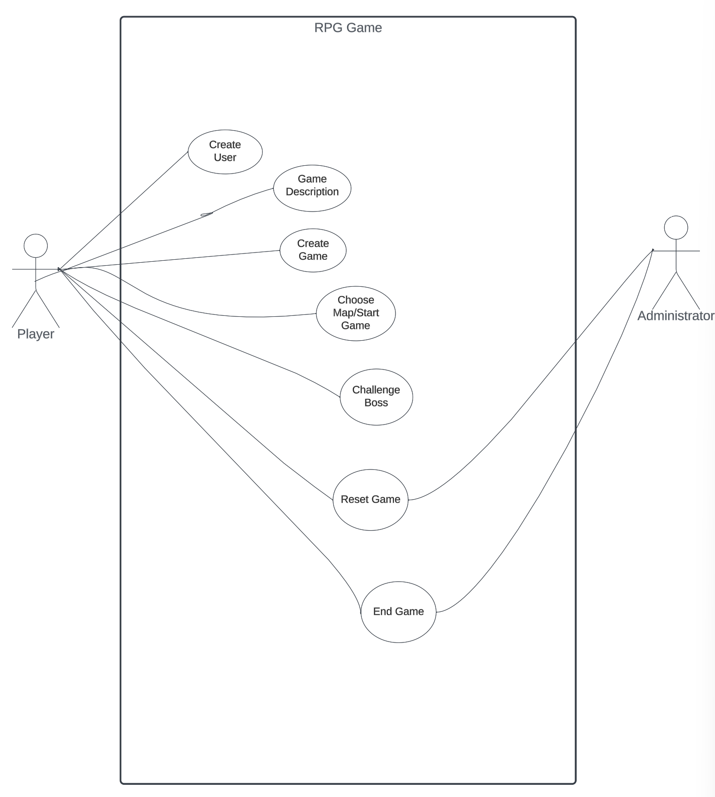

## Use-Cases Diagram Description

|  |  |
| --- | --- |
| Name: | Create User |
| ID | RPG_01 |
| Brief Description. | The user can provide a name, which will appear on the game screen; however, if the user does not feel comfortable giving the name, the game software will default the player’s name to Bob. |
| Actors  Primary/Secondary | Player. |
| Triggers | New user who wants to play the game. There is no save game for now; therefore, returning users will have to start from square one. |
| Precondition | None |
| Primary Flow | 1. Player provides the name. 2. Start options will be displayed on the main screen to continue. 3. Exit button will be available if the player doesn’t want to continue. 4. The player refuses to provide name but want to continue. 5. Repeat option one workflow. 6. The player refuses to provide name and does not want to continue. 7. Exits game. |
| Alternative Flow | None. |
| Minimal Guarantee |  |

|  |  |
| --- | --- |
| Name: | Game Description |
| ID | RPG_02 |
| Brief Description. | The player will be welcomed, and the game description is provided. |
| Actors  Primary/Secondary | Player. |
| Triggers | User must initiate Create User case for this action. |
| Precondition | None. |
| Primary Flow | The user reads instructions and clicks button to continue. |
| Alternative Flow | None. |
| Minimal Guarantee |  |

|  |  |
| --- | --- |
| Name: | Create Game |
| ID | RPG_03 |
| Brief Description. | Players will check the initial stats and how they will be distributed and start the game button to create the game. |
| Actors  Primary/Secondary | Player |
| Triggers | Game Description. |
| Precondition | Players must follow the previous step to create the game. |
| Primary Flow | Because it is the initial phase, the player will receive five free points to play the game, and they don’t have to do anything else but start the game. |
| Alternative Flow | Player can manipulate or rearrange the stats in which the options are the following:   1. Strength 2. Dexterity. 3. Vitality. 4. Intelligence.   By changing the above settings, the player will lose one point for each change. |
| Minimal Guarantee | N/A |

|  |  |
| --- | --- |
| Name: | Choose Map/Start Game |
| ID | RPG_04 |
| Brief Description. | After the game is created, the player will have three paths, each with a map. When a path is chosen, and the player starts selecting the given options, the player will be able to see their location on the map. |
| Actors  Primary/Secondary | Player |
| Triggers | N/A |
| Precondition | Start the Game. |
| Primary Flow | Players will read a message stating which part of the ship they want to explore/clean first. Also, before the player starts the game, they can double-check the stats and readjust them if needed. The inventory option will also be available on the main screen.   1. Entering a room: 2. Nothing happens and can rest after a battle. 3. Chest is found and key is needed to open. If lucky, good items can be found and taken. 4. Villains in the room and player goes into battle mode, or they can run. |
| Alternative Flow | N/A |
| Minimal Guarantee | N/A |

|  |  |
| --- | --- |
| Name: | Challenge Boss |
| ID | RPG_06 |
| Brief Description. | To clear the room or current map, the player must face a stronger opponent(boss); defeating this character will make the player move to the next level. |
| Actors  Primary/Secondary | Player. |
| Triggers | Overcome all challenges that are assigned in each map. |
| Precondition | Chose Map. |
| Primary Flow | After clearing all the previous rooms and arriving at this stage, the player is worn out but collects different items to help them get back in shape(energetic). However, that last room, where the big boss resides, has a different feeling than the previous rooms in which the player realizes he is in trouble. What will he do?   1. **Fight:** The player defends himself and applies skills gained from previous battles. 2. **Run**: the main door is locked upon entrance.    1. Other doors are available but will suck him out of the battleship. |
| Alternative Flow | If the player did not collect boost items and does not have enough to face boos. Reset game for that specific map. |
| Minimal Guarantee | N/A |

|  |  |
| --- | --- |
| Name: | Reset Game |
| ID | RPG_07 |
| Brief Description. | Players did not collect enough items to fight, boss can reset game, or if there is an issue with the software, administrator can rest the game without losing players collected items. |
| Actors  Primary/Secondary | Player  Administrator |
| Triggers | Unable to defeat boss or software issue. |
| Precondition | N/A |
| Primary Flow | 1. Because players must accumulate points and stats to play against the main villain character, they should have what it takes for the battle. However, if the player cannot win, he can reset the game and start again. 2. If the player cannot finish the challenge because of a software issue, the administrator can work on the problem and reset the game without losing the rewards collected if:    1. It is a software issue (bug)    2. A player testing the software. |
| Alternative Flow | N/A |
| Minimal Guarantee | N/A |

|  |  |
| --- | --- |
| Name: | End Game |
| ID | RPG_08 |
| Brief Description. | When opting to end game, player’s window will be terminated and will have to start all over again (for now). |
| Actors  Primary/Secondary | Player  Administrator |
| Triggers | Finish all Leves |
| Precondition | N/A |
| Primary Flow | These options will be available for every player if they want to terminate the game anytime.  Players will be warned that they cannot recover any record if they want to log back in by closing or ending the game.  If it is determined that the player is cheating the system, the game will be terminated as well. |
| Alternative Flow | Reset Game |
| Minimal Guarantee | N/A |

## Natural Language Requirements

[Include requirements here]

## Traceability Matrix

[Include traceability (matrix) from requirements to use cases]

# Design

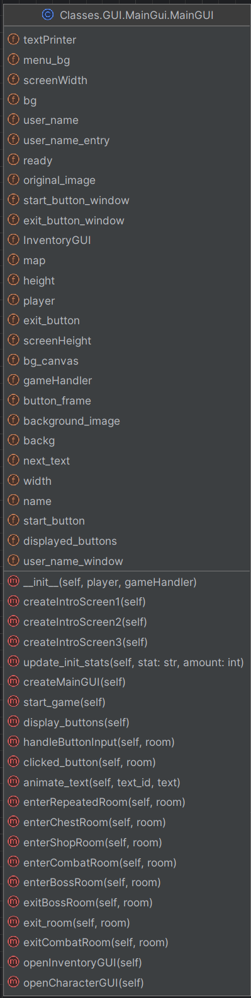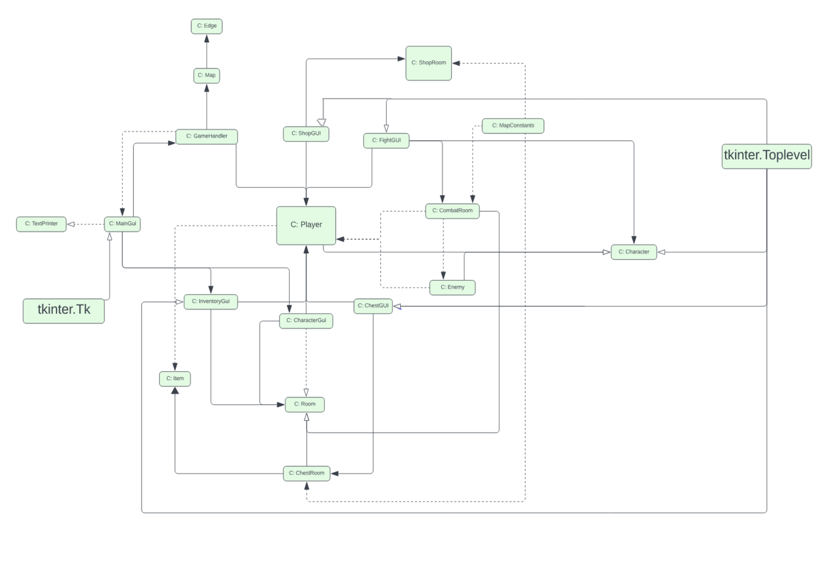The class diagram below was designed using Lucidchart, and because some of the classes contain a lot of instances and methods, we decided to include the Class name only. An example of the MainGui class is shown below the class diagram displaying detailed information.

Development

[Description of methods used (e.g., Checkstyle, PMD, Javadoc) AND any additional libraries that you used]

## Code Standards

[Include report on code standards and justification for any variances]

## Static Analysis

[Include report on static analysis and justification for any variances]

## Code Documentation

[Include link to javadocs (likely included as separate file) and justification for any non-documented areas]

## Configuration Management

Since we were using git/GitHub to track our project, each group member worked on developing the game software and pushed it into the remote repository when possible. Although we did not have a team lead, Eric would briefly describe what needed to be done so we could work on it when possible.

When committing the changes, we started with a brief description of each group member's changes. However, it took effort to follow sometimes, and we discussed that a detailed description would help us understand the changes better.

Although we did not write detailed information when committing, we used Discord constantly to describe what was done after pushing the changes to the GitHub repository; thus, it helped us better track the changes.

The URL address for the project is listed below.

<https://github.com/Evickerest/rpg.git>

# Verification

[Description of methods used (e.g., integration & systems and/or unit testing)]

## Integration Tests

[Include manual and integration test procedures]

## Unit Tests

[Include references to unit tests in code]

## Code Coverage

[Include code coverage reports, must include: coverage of automated tests, coverage of manual tests, and combined coverage]

## Requirements Coverage

[Include traceability (matrix) from requirements to test procedures]

# Postmortem

[Include a reflection on how well the project has gone thus far]

## Earned Value

[Include the earned value calculations for your current status and any explanation of over/under runs]

## Variances

[Include any additional variance (time, coverage, functionality, …) explanations necessary]

## Lessons Learned

[Include lessons learned]

# Work Cited

*Artworks by Artists from around the World | Artstation*, www.artstation.com/marketplace/game-dev/artworks. Accessed 7 Mar. 2024.

Creative, Make It. “Lights and Shadows: Sci-Fi Lift: After Effects.” *Behance*, 1999, www.behance.net/gallery/44429607/Lights-and-Shadows-Sci-fi-lift-After-Effects.

“Inside a Sci-Fi Spaceship Escape Pod That Is a Mind: Stable Diffusion.” *OpenArt*, openart.ai/discovery/sd-1006280114948030534. Accessed 9 Mar. 2024.

“Lifegoods.Com.” *MY*, my-lifegoods.com/. Accessed 9 Mar. 2024.

Santamarian, Ioana. *Retro Sci-Fi Kitchen, Ioana Santamarian*, 2019, www.artstation.com/artwork/2xZYWJ.

“Sci Fi Space Station Interior in Environments - UE Marketplace.” *Unreal Engine*, 1999, www.unrealengine.com/marketplace/en-US/product/sci-fi-space-station-interior.

*Sci-Fi Hangar Concept, Daniel Jakobi*, www.artstation.com/artwork/klgkbx. Accessed 7 Mar. 2024.

“The SHIPMAS Season Approaches: Countdown to 9 New Star Atlas Spaceships.” *Medium*, Star Atlas, 10 Dec. 2021, medium.com/star-atlas/shipmas-9-new-star-atlas-spaceships-f24afc7956b1.

“Spaceship Cabin.” *Cool Ideas in Photos*, en.idei.club/8121-spaceship-cabin.html. Accessed 1 Mar. 2024.

“Spaceship Hallway C4d 1920x1080 by Xcustomgraphix on DeviantArt.” *By xCustomGraphix on DeviantArt*, www.deviantart.com/xcustomgraphix/art/Spaceship-hallway-C4D-1920x1080-407417487. Accessed 7 Mar. 2024.

*Wallpaper Abyss - HD Wallpapers, Background Images*, wall.alphacoders.com/. Accessed 9 Mar. 2024.